CONSTRUCTION FEATURES
The oil vapour emissions are controlled by a separator (1) which collects the vapours released from the crankcase using the pipe (2).
The difference in temperature between the separator and the oil vapours causes partial condensation.
The uncondensed vapours are sent, through a pipe (3), to the turbocharger air inlet hose.
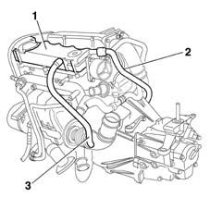

CONSTRUCTION FEATURES
A regulating valve on the rocker cover, consisting of a spring (1) and diaphragm (2), prevents faulty intake phenomena.
When the vacuum values present under the rocker cover exceed a specified limit, the diaphragm moves downwards and blocks the pipe coming from the crankcase.
